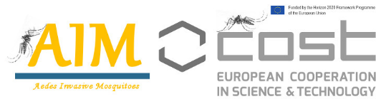
COST Action CA17108
Aedes Invasive Mosquitoes
www.aedescost.eu
Verification Sheet
Short Term Scientific Mission

Personal data:
First name

Last name

Gender

Age

Home Institution

Country

E-mail

Early Career Investigator | Yes |  | No

STSM data:
Topic of the STSM

Host Institution

Start date

End date

Working Group (WG)

Herewith I declare that I did not participate in an STSM of the CA17108 Action in the current grant period nor in a CA17108 STSM in the same host institution since the beginning of the Action.

Check list (please verify all items below, to avoid disqualification):
You have written the topic of the STSM in the online application form.

You have obtained and attached the written agreement of the host institution

You have attached your Curriculum Vitae

You have completed and attached the full work plan

You have completed and attached a motivation letter

You have obtained and attached a letter of support from the Home institution

The requested budget is in compliance with COST rules and MC decisions of CA17108

The period of the mission is according to the specific recommendations for this call

The Working Group is specified

This Verification Sheet is filled-in and attached to the application

According to COST, within 8 years after completing a PhD/Doctorate degree. PhD students are NOT considered early career investigators.

